BACKGROUND

The global economy is a complex and constantly changing web of many variables such as trade, income, investment, aid, Gdp etc.. A change in any of these variables in one part of the world will result in changes in other variables throughout the world. The study of the global economy involves many complex concepts but much can be understood through mapping some of the more common variables.

Gross Domestic Product (GDP)
GDP is one measure of economic activity, the total amount of goods and services produced in a country in a year. It is calculated by adding together the market values of all of the final goods and services produced in a year.
* It is a gross measurement because it includes the total amount of goods and services produced, some of which are simply replacing goods that have depreciated or have worn out.
* It is domestic production because it includes only goods and services produced within the country.
* It measures current production because it includes only what was produced during the year.
* It is a measurement of the final goods produced because it does not include the value of a good when sold by a producer, again when sold by the distributor, and once more when sold by the retailer to the final customer. We count only the final sale.
Changes in GDP from one year to the next reflect changes in the output of goods and services and changes in their prices. To provide a better understanding of what actually is occurring in the economy, real GDP is also calculated. In fact, these changes are more meaningful, as the changes in real GDP show what has actually happened to the quantities of goods and services, independent of changes in prices.

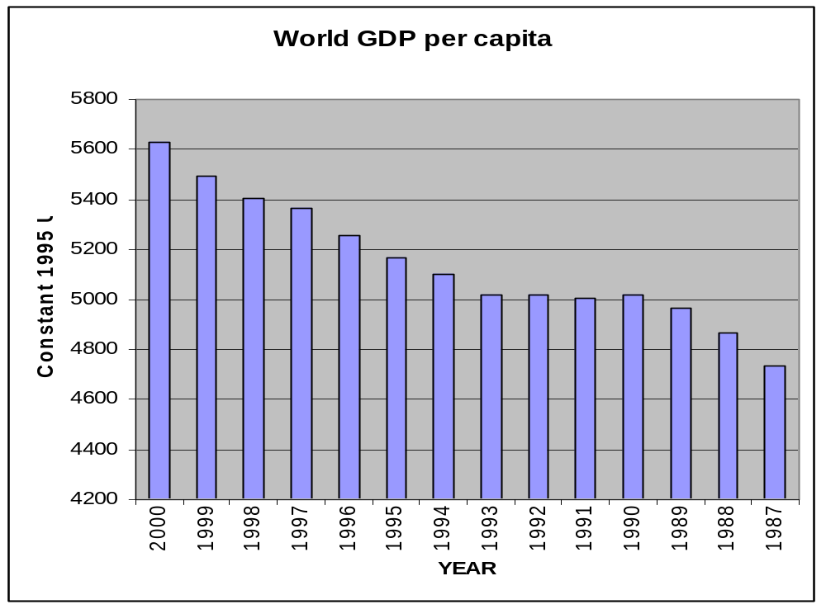

EXTERNAL DEBT

Data on external debt is widely recognized as among the most
challenging sets of data to collect and use. This is apparent even from the definition of external debt. The so-called core definition agreed by the international organizations that collect debt data is as follows:

Gross external debt is the amount, at any given time, of disbursed and outstanding contractual liabilities of residents of a country to nonresidents to repay principal, with or without interest, or to pay interest, with or without principal.
This wording was carefully chosen. For example, the term Gross external debt makes explicit the exclusion of any corresponding offsetting assets or claims. The term contractual liabilities is intended to cover a broad range of obligations, but to exclude equity participations, which do not involve a requirement to make principal or interest payments. However, it was recognized that new interpretations might be needed given the pace of innovations in financial markets, and currently there is a question whether financial derivative instruments are covered.

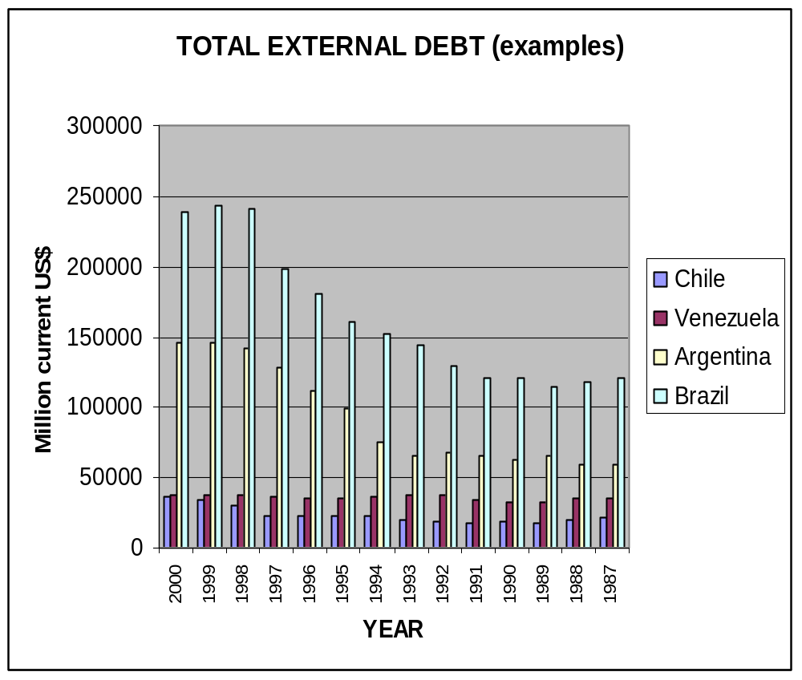

The graph shows Argentina and Brazil with increasing debt and therefore increased financial difficulty.

Direct foreign investment
Financial assets and liabilities that are associated with direct foreign investment - both outward and inward - are to be recorded under the appropriate financial assets listed in the classification, i.e., shares and other equity (including reinvested earnings), loans, and other accounts receivable and payable. These direct investment-related entries also are to be recorded separately as a memorandum item.
The net financial claims of an economy on the rest of the world, i.e., external financial assets less financial liabilities, often are the basis for characterizing an economy as a "net creditor" or "net debtor". Such a label is not accurate as a depiction of the net external position of the economy. Rather, it is more relevant to view only the non-equity components of the external balance sheet as debt, i.e., all recorded liabilities other than shares and other equity. This view is in general concordance with the "core" definition of external debt/4 in External Debt: Definition, Statistical Coverage, and Methodology (1988), a joint study by the IMF, World Bank, OECD, and the Bank for International Settlements.
Particularly for countries experiencing external debt problems, identifying debtor and creditor sectors for the rest of the world and counterpart domestic sectors is of analytical importance. The three-dimensional tables provided in the System show the links between debtor and creditor sectors, such as foreign sources of financing, etc., and can be supplemented or rearranged to identify such items as debt reorganization, arrears of interest and amortization, etc. In this respect, the Balance of Payments Manual covers specific recording procedures for the above and other "exceptional financing" entries in the international accounts.
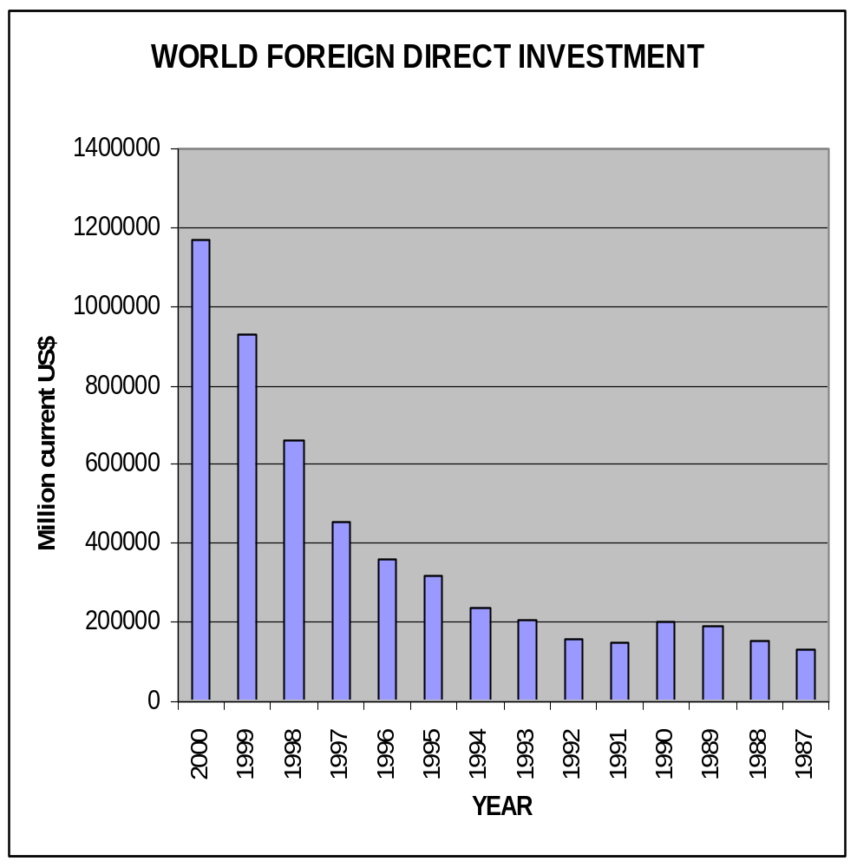

DEVELOPMENT ASSISTANCE:

Development Assistance is aimed at promoting economic and social growth
through smallholder assistance, enterprises, and human development
through loans, technical, and monetary aid. Development Assistance is
usually characterized by the following categories: population and
family planning, agriculture and food security, education, public
health, democracy promotion and elections, economic development, and
emergency assistance. Development Assistance faces many challenges and
can take many new directions in the twenty-first century. Donor
nations, like the U.S., must find a way to make Development Assistance
promote sustainability without creating dependency and dictating the course of development.

The idea of Development Assistance came out of the post-World War Two
Marshall Plan to reconstruct Europe. It was seen as a way to shift from
extreme militarization to social and economic development through
monetary and technical assistance. For Africa, Development Assistance
came out of the end of Western colonial rule and the beginning of the
Cold War. Many African States aligned with the U.S. or the Soviet Union
as proxies and competed for large portions of economic and military
assistance. In 1961 Kennedy signed the Foreign Assistance Act that
created USAID, an independent government bureaucracy that oversees
Development Assistance projects. Development Assistance has gone
through three phases in its history. Phase I (1960's through the early
1970's) was mostly bilateral assistance from former colonial powers
(Britain, France, and Belgium), as well as Canada, the U.S., Norway,
and the Soviet Union (Bandow and Vasques 128). Phase II (1970 to 1989)
saw the rise of multilateral institutions. Multilateral development
institutions became important donors of development assistance. These
include: the IMF and World Bank, the European Development Bank, OPEC,
the International Fund for Agriculture Development, the UN Development
Programme, the Arab Bank for Economic Development in Africa, the
African Development Bank, and the Commonwealth Development Corporation.
In this era assistance for multilateral development banks grew from 13%
to 34% by the end of 1987. Phase III (the post-Cold War era) has seen a
decline in Development Assistance budgets. With Africa no longer
serving a geopolitical interest in the battle with the U.S. and Soviet
Union, Sub-Saharan Africa saw the slashing of budgets and a decline in
relations with foreign powers. This makes no a particularly important
turning point to donor relations. It is a unique opportunity to discuss
the need for the expansion or even the necessity to continue
development assistance.

